Jenkins is a popular open-source automation server that is used to build, test, and deploy software.

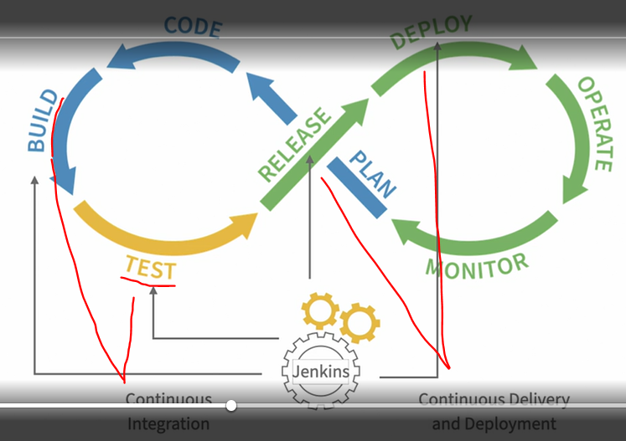

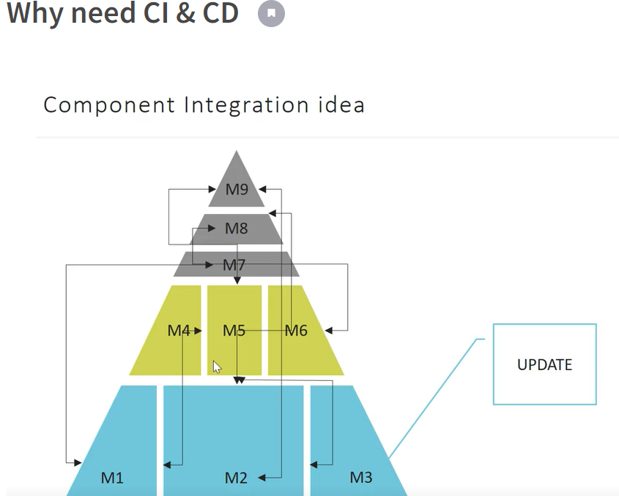

Why we need Continuous integration

Problem: we have different teams that work with different modules of system and do not communicate until some release date, separately modules can work perfect but they could possibly understood and develop feature in their own way without communication with other teams in result in date of release it will come integration hell moment when all services have to be joined in one system.

Resolution: To delegate all process of system integration to for example Jenkins which will automatically after each commit\patch\version will trigger different kind of test verifications on different related modules and in case of success result will push artifacts(deploy) to another environments qa\uat

Continuous Integration concept:

Developer commit new feature to VCS this action will trigger all cycles of tests in different levels – unit – service – ui, if in some step failure arise, feature will not be deployed to environment and developer will be notified, if no failure feature will be ready for deployment

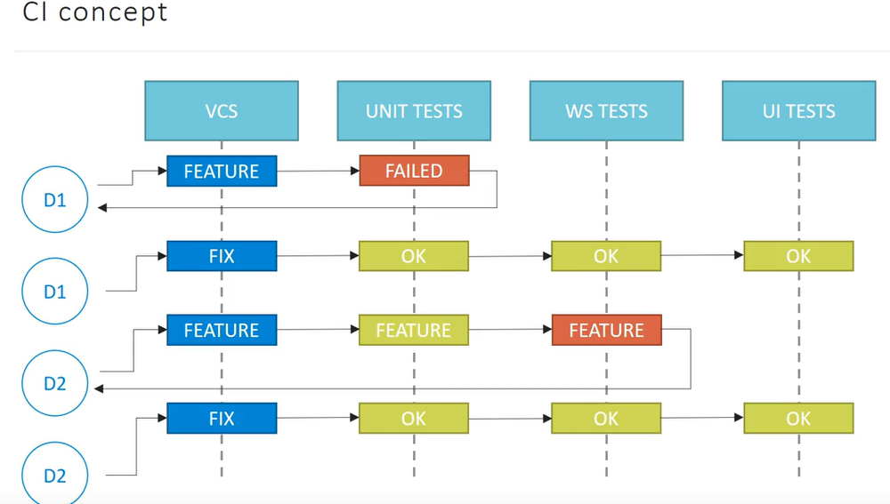

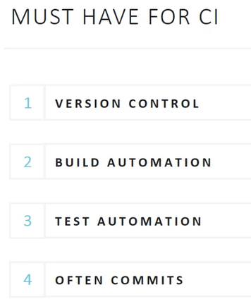

Continuous Delivery:

Developer make commit a feature – all tests passed – feature automatically deployed to production environment and can be visible for users. Mostly we use continuous deployment, so without viewing new features to end users

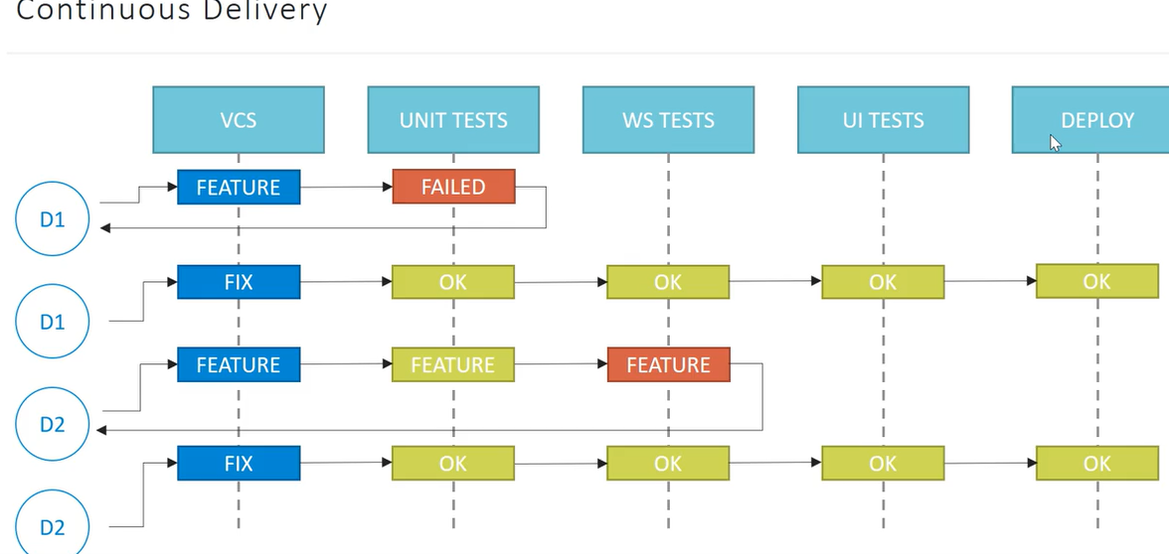

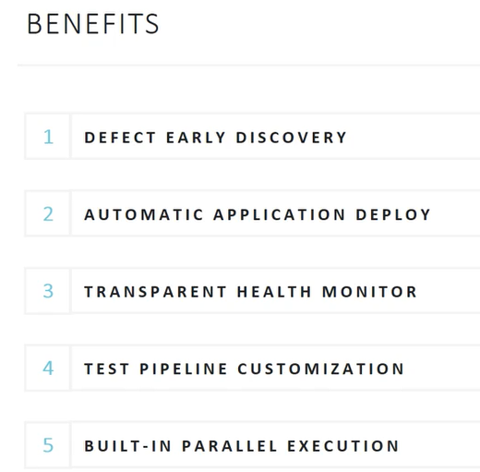

Build-in parallel execution – can run tests on different machines on cloud remotely

Job – a set of instructions that Jenkins must follow and manage to complete your task.

Build – one run of job

Build step - can be a task for Jenkins

Build trigger – event that starts a build or cause it

Plugin – is an extension to core Jenkins functionality

Global tool configuration:

Manage Jenkins – Global Tool Configuration

Used to set basic tools for build processes it will be installed at very first time you will need maven to run

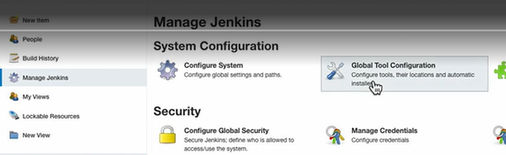

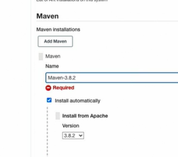

Jenkins job types:

Freestyle project

Pipeline – can run build steps in parallel, skip steps and perform steps on different platforms

Multiconfiguration project – used for jobs with same build steps but different combinations of parameters

Folder – not a job, used to group jobs into groups

Git Hub Organizations – search in repository for Jenkins files to configure jobs automatically

Multibranch pipeline job – same as git hub organization but can do it for different branches in one repo

Job Settings:

General:

Description

Discard old builds – how long or how many builds\artifacts to store, it take place of server so better to configure

Source Code management

Select repo than specify branch from which Jenkins will get code for build

Build triggers:

By default, it started manually

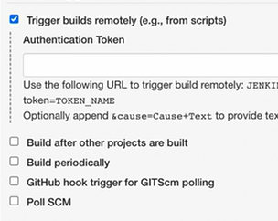

Poll SCM – will look in repo for changes by schedule and it’s better to use git hub hook as it used less resources

Build Environment:

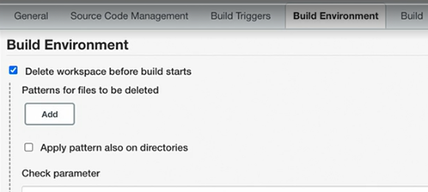

Configuration of deleting workspace before start of new job or in advance mode some specific directories

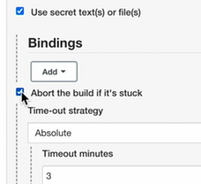

Condition to abort work of job if it is blocked and can not finish normally, set some maximum time for job work

Build:

Here you select type of build steps and describe what they have to do. Can add pre\post build step

Run a job:

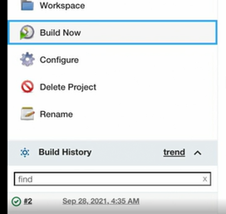

Click Build now and check the results

Console Output:

Click on run status to open console output

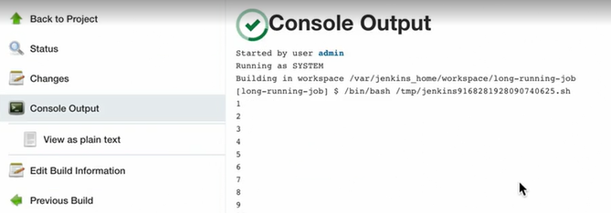

Build Trend:

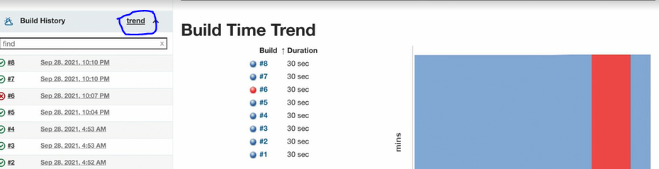

Workspace:

This is a place where job stores all generated files during the build

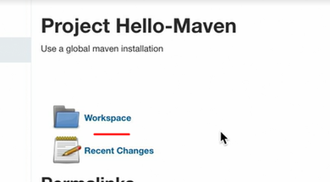

To clear Workspace manually click here

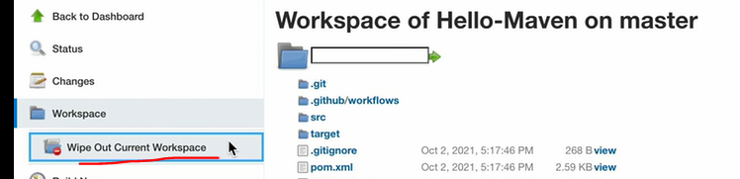

Artifacts:

generated files after build: reports, wars, exes, jars

To store artifacts, you need to add post build step, then specify file to archivate

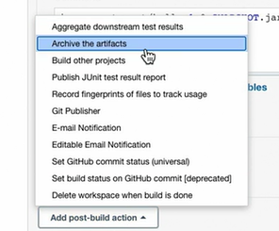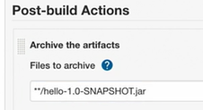

After that you can check the results under the Workspace

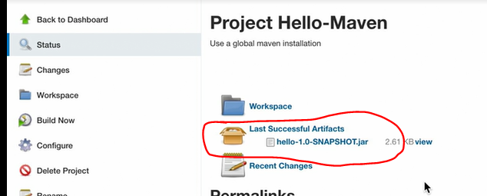

Build Parameters for windows used as environment variables:

Specify variable

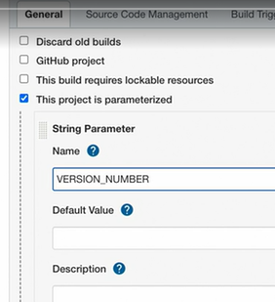

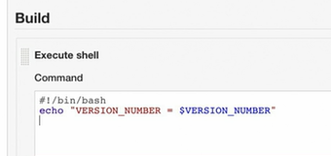

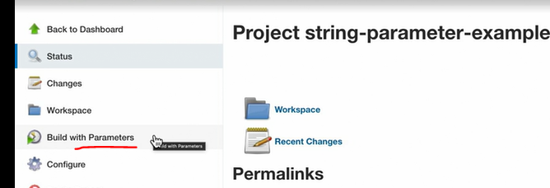

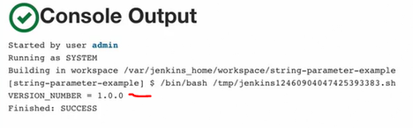

Choice parameter

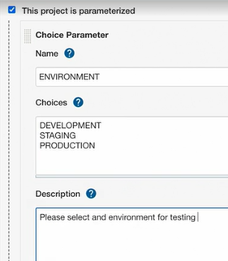

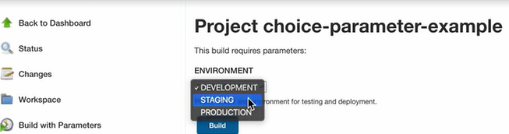

Boolean parameter:

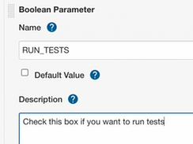

Scheduling jobs:

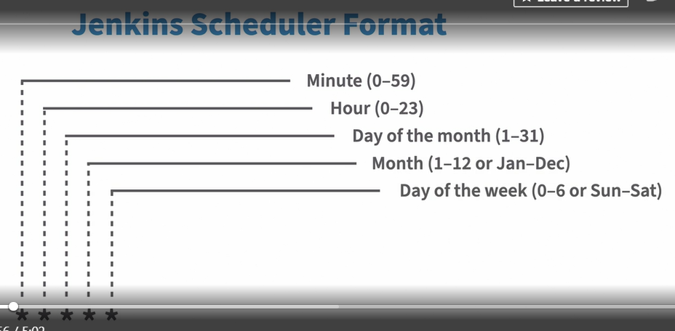

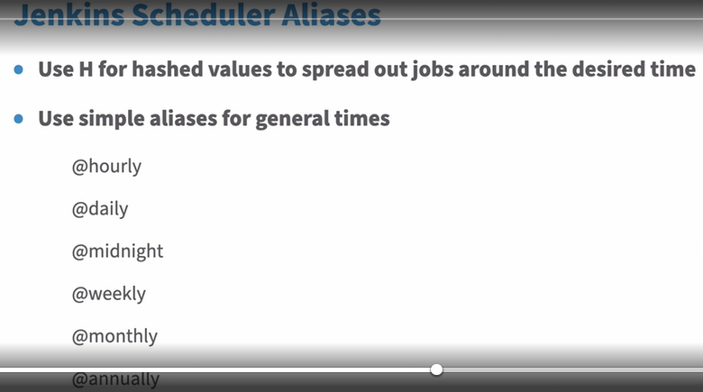

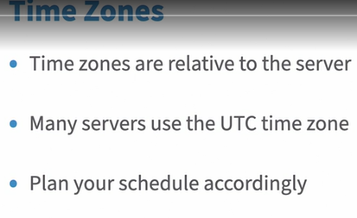

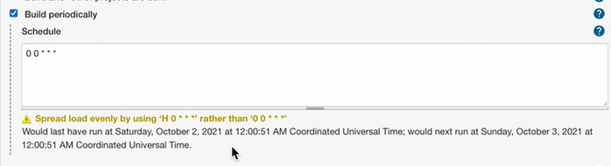

Views:

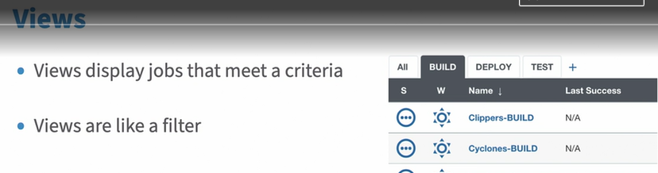

Views has access to the jobs at that level where they have been configured so if we drop all jobs to folders views on top level will become empty – by default

But we can change it by command

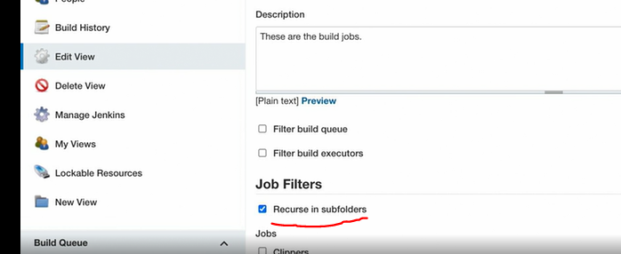

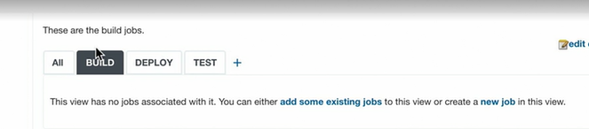

If we delete a view all jobs inside the view will continue to exist.

Folder:

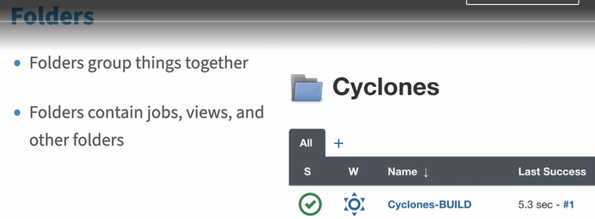

Move job to folder:

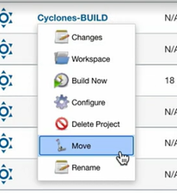

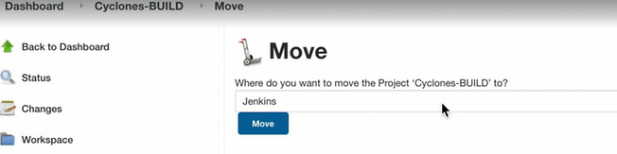

If we delete a folder all jobs inside the folder will be deleted as well.

Pipeline:

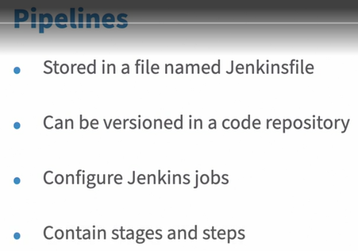

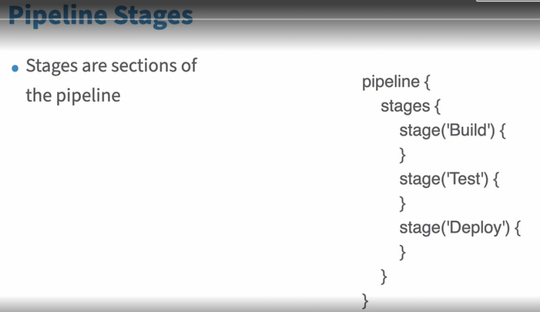

All stages have at least one step

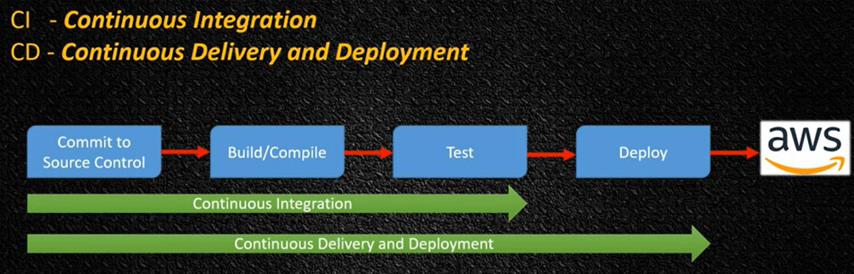

CI/CD - это подход к [разработке программного обеспечения](https://ru.wikipedia.org/wiki/%D0%9F%D1%80%D0%BE%D0%B3%D1%80%D0%B0%D0%BC%D0%BC%D0%BD%D0%B0%D1%8F_%D0%B8%D0%BD%D0%B6%D0%B5%D0%BD%D0%B5%D1%80%D0%B8%D1%8F" \o "Программная инженерия), при котором программное обеспечение производится короткими итерациями, гарантируя, что ПО является стабильным и может быть передано в эксплуатацию в любое время, а передача его не происходит вручную

Про деплой - <https://guides.hexlet.io/ru/deploy/>

Деплой — процесс «разворачивания» веб-сервиса, например, сайта, в рабочем окружении.

Рабочее окружение — место, где сайт запускается и доступен для запросов.

Продакшен — это среда запуска (иногда говорят боевая среда). В случае простого приложения она может состоять из одного сервера, а может — из тысяч

Разработчики добавляют код в репозиторий. В какой-то момент они решают, что пора доставить его до продакшена.

Деплой нужно максимально автоматизировать, от этого зависит Time To Market — ключевая характеристика бизнес-ориентированных приложений. Чем быстрее и чаще мы доставляем изменения пользователю, тем лучше.

Zero Downtime Deployment

Zero Downtime Deployment выглядит так, как будто сервис никогда не останавливается, но при этом обновляется. Достигается это за счет одновременного запуска старой и новой версий кода. То есть, когда деплоится приложение, то сначала поднимается новая версия рядом со старой. И только когда автоматика убеждается, что новая версия запустилась и работает, происходит остановка старой версии.

Where all Jenkins configs and workspace stores:

C:\ProgramData\Jenkins\.jenkins

Jenkins Nodes:

Plugins: SSH Agent, SSH Master

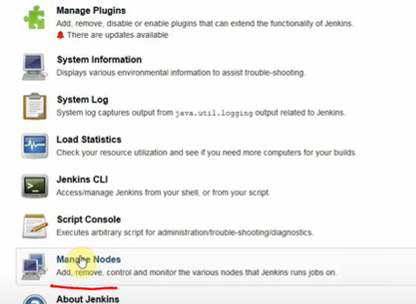

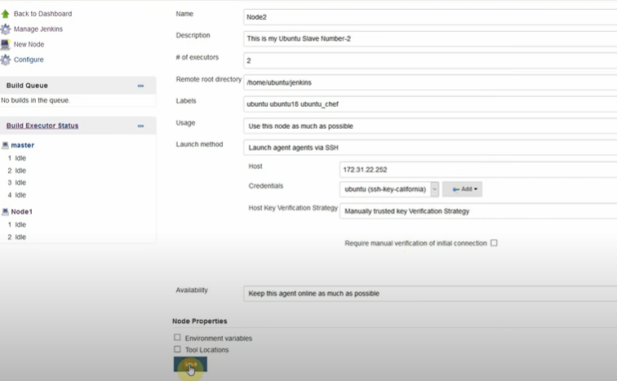

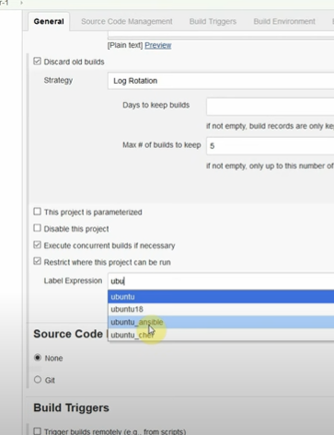

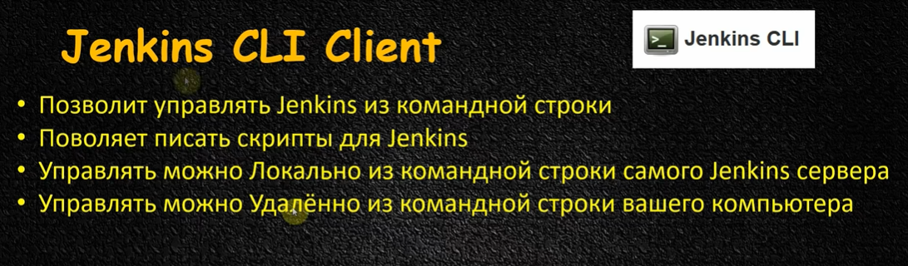

Connect to github via SSH:

Geberate SSH key pair by command from github documentation

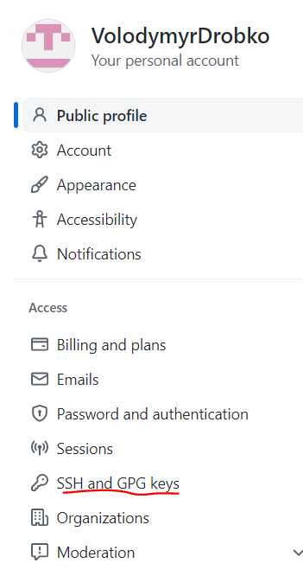

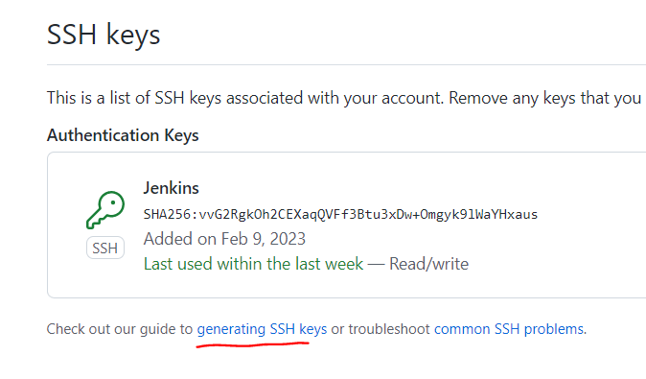 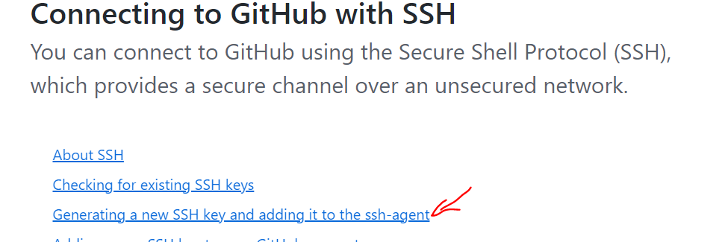 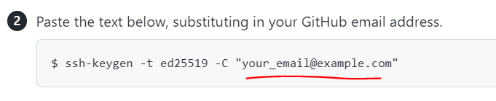

The format can be different: Use your github mail: 3 times click enter

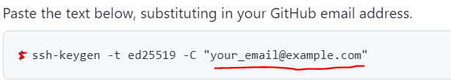

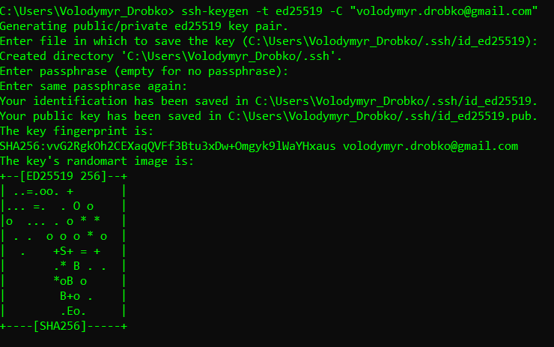

You will receive private and public keys and .ssh directory will generate in your user folder:

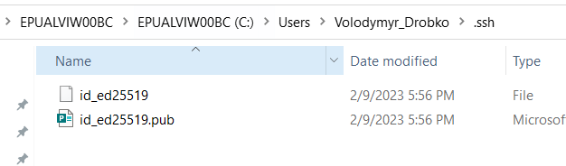

You have to add public key to github:

Account – Settings – SSH and GPG Keys – click New SSH key

Give it a title you want: git-jenkins-ssh-key

Insert public key

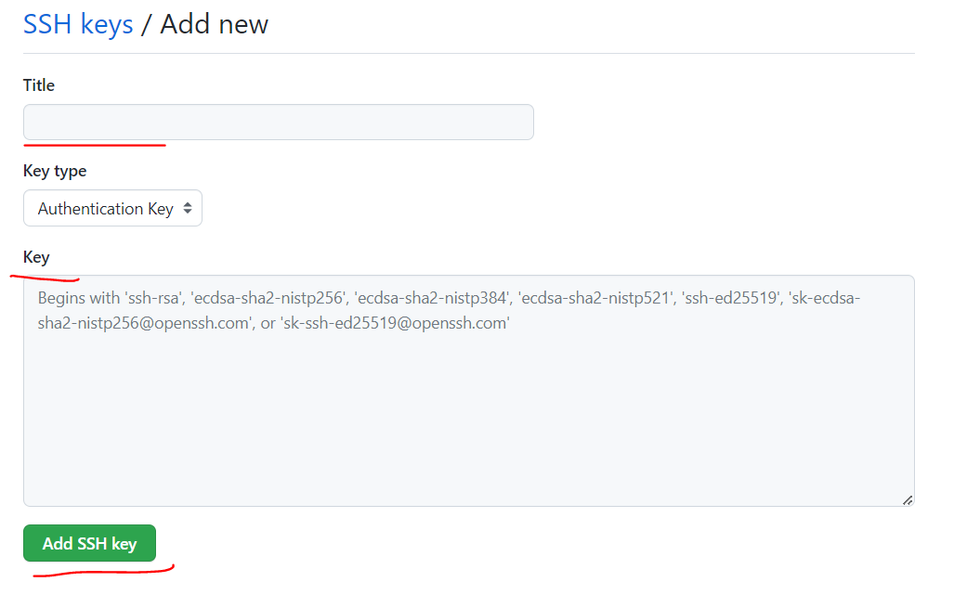

To get keys from cmd gp to .ssh and perform command type name_of_public_key



Same for private:

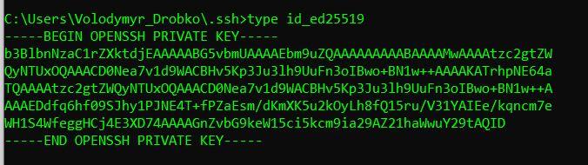

Go to Credential Management and click add new creds near your global or any needed account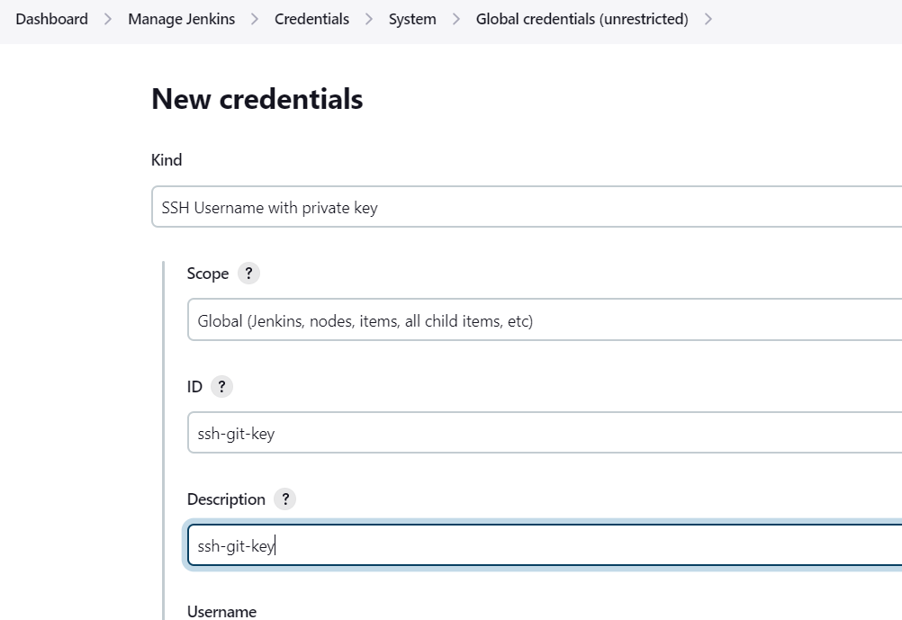

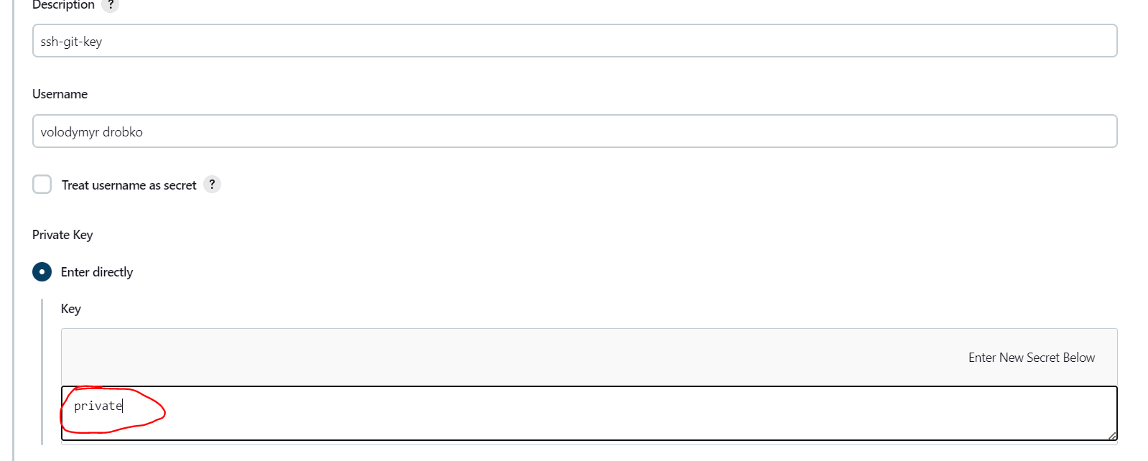

Also go to Global security and set up known host strategy to Accept first Connection

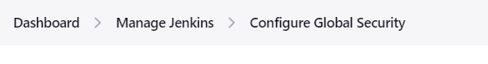

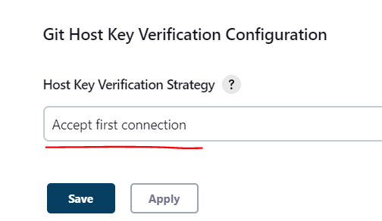

Than you can configure your job with new ssh creds and pair it with your repo by SSH

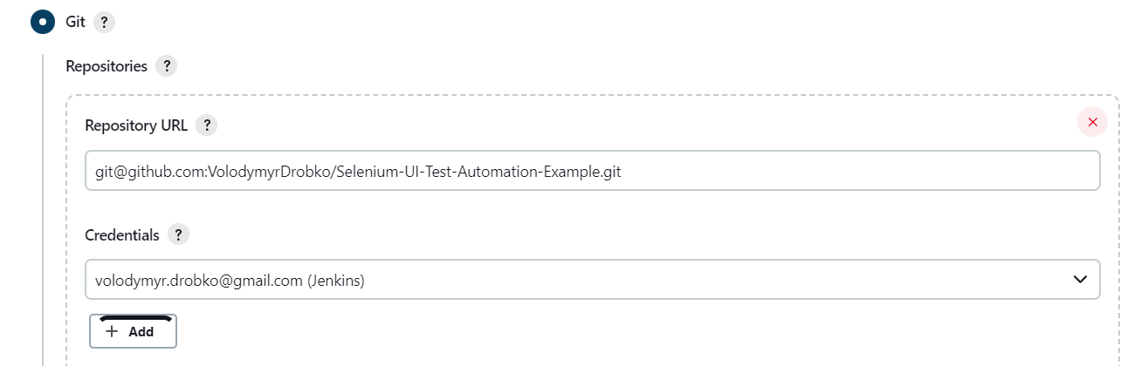

Jenkins CLI:

Generate token in User Configuration

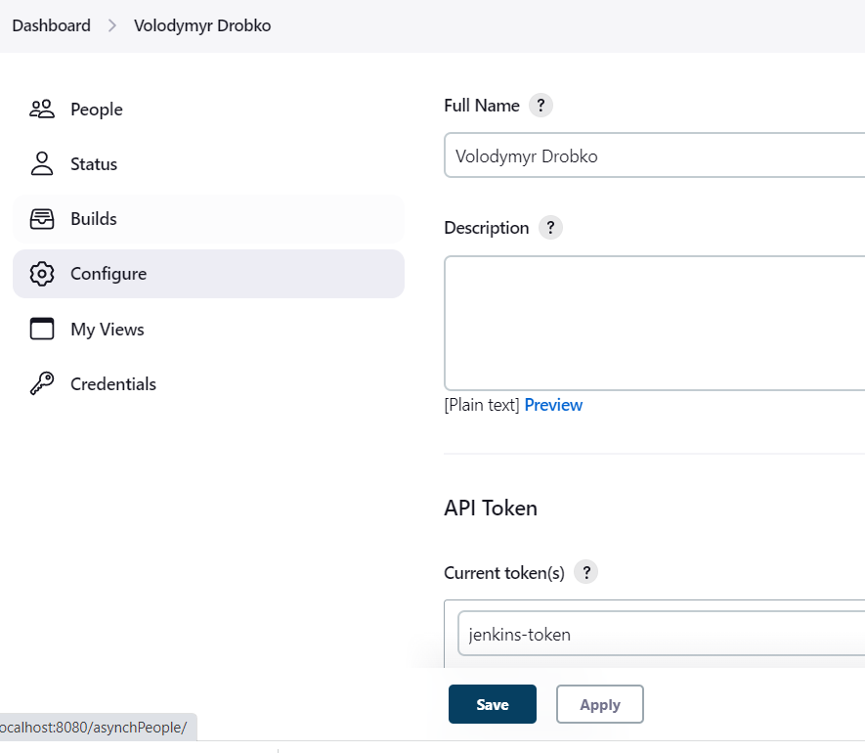

Download cli from Jenkins and start it with authentication



It allow you to control your Jenkins remotely

Role Based Strategy for managing users

Plugin: [Role-based Authorization Strategy](https://plugins.jenkins.io/role-strategy)

Go to Global Security and check Role Authorization strategy

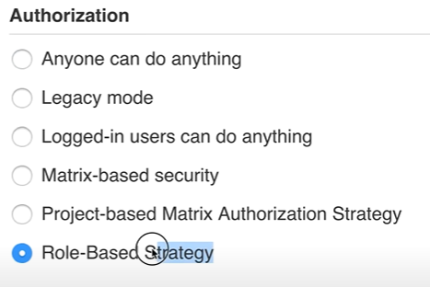

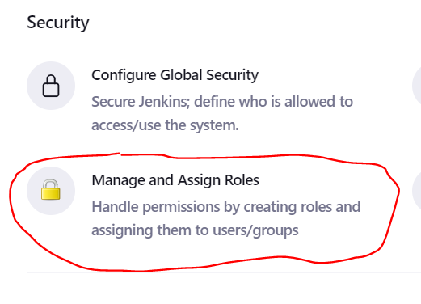

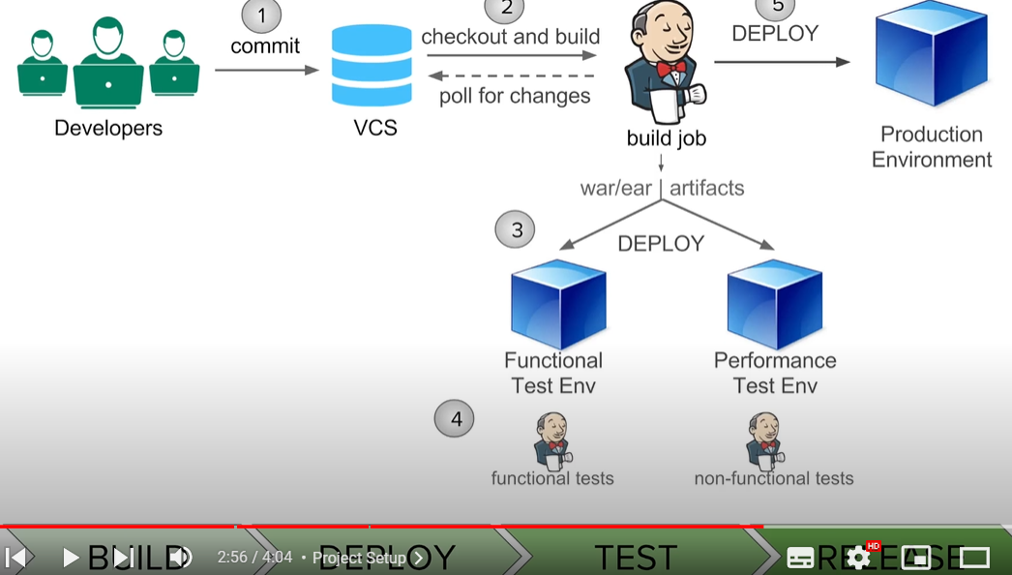

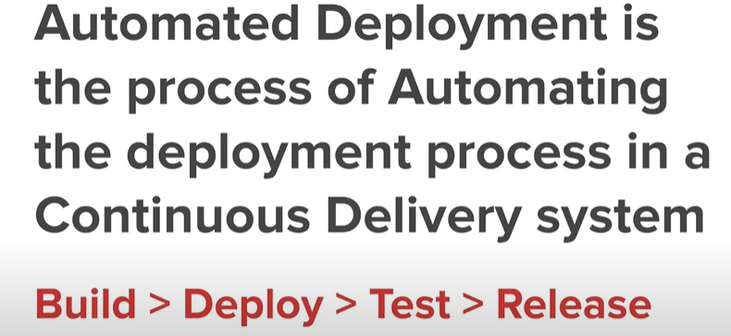

How to use env variables from Jenkins

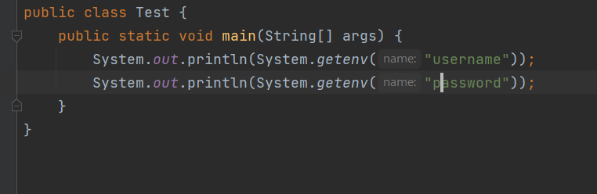

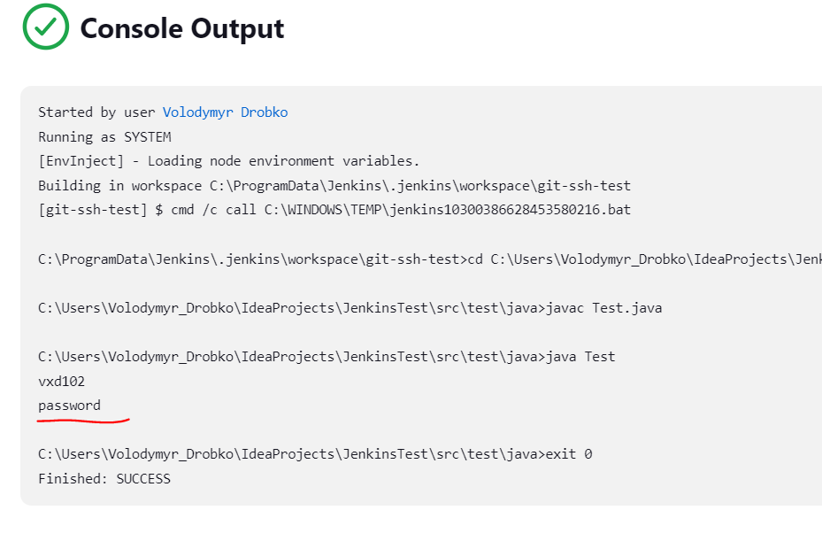 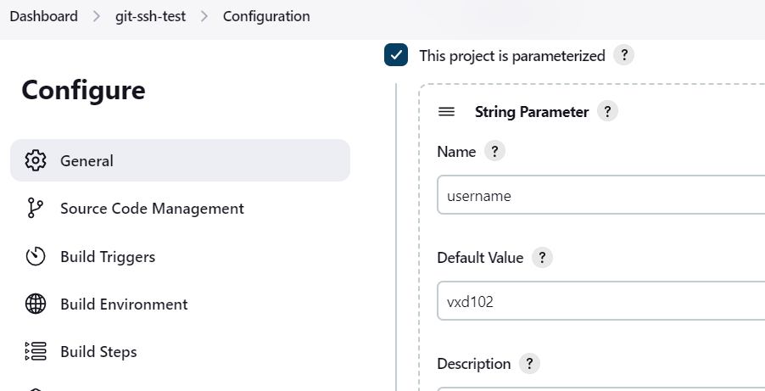

Artifacts:

To show results from previous run:

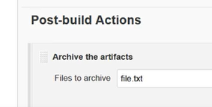

We can also copy artifacts from one job by another job

Purpose: first job can build project and generate some executable file with tests for example and another job or several(artifact receivers) can get those exe to run tests(unit, services, ui) to omit steps duplications.

Plugin: Copy Artifact

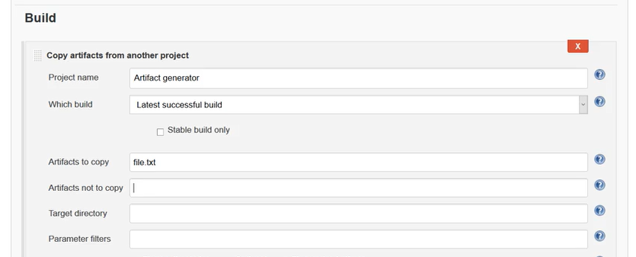

Pipeleine:

Plugin: Build Pipeline view

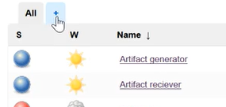

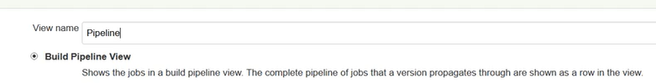

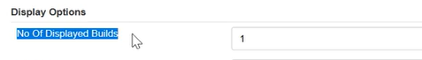

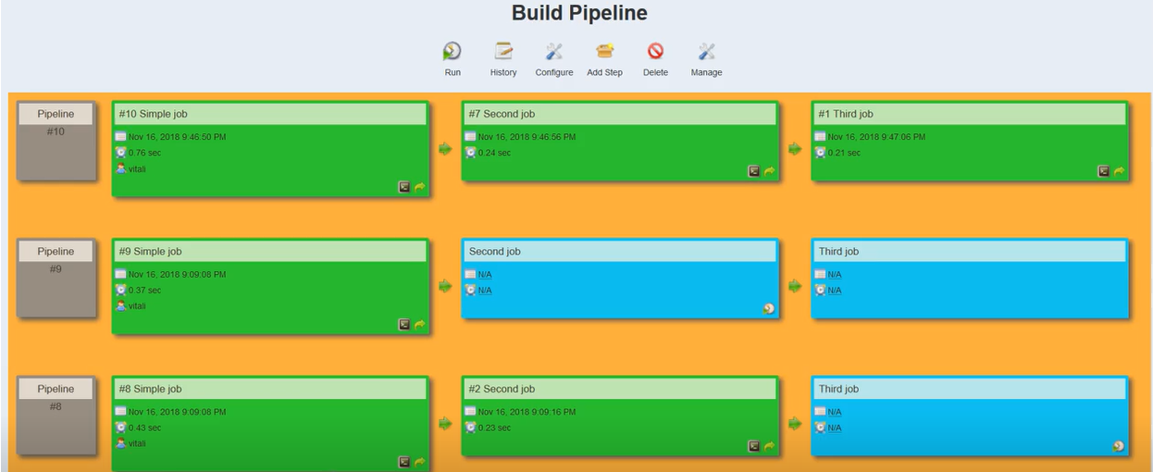

Jenkins management

Jenkins backup plugin to store importand information

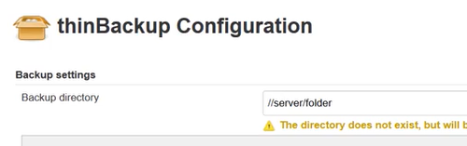

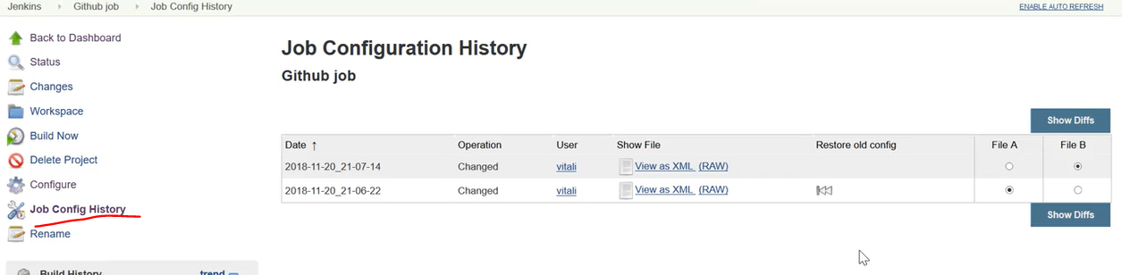

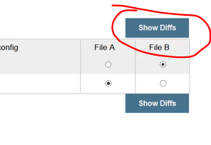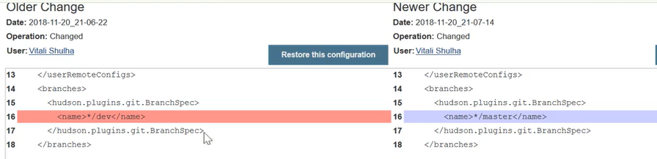

Delete Jenkins

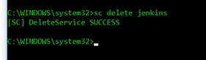

Jenkins run configuration

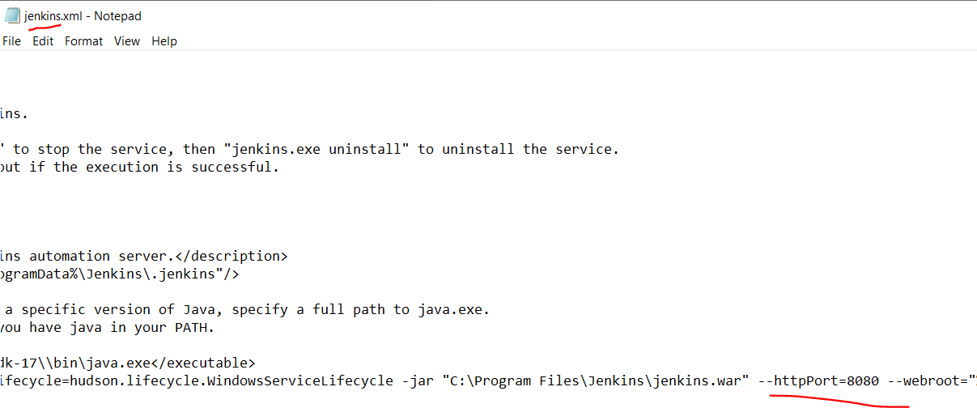

Build Triggers:

H – hash for optimization of run, it helps Jenkins to select which job and when to run

H/5 – mean every 5 minutes or hours or days, depends on crone symbol H/10 – every 10 and so on

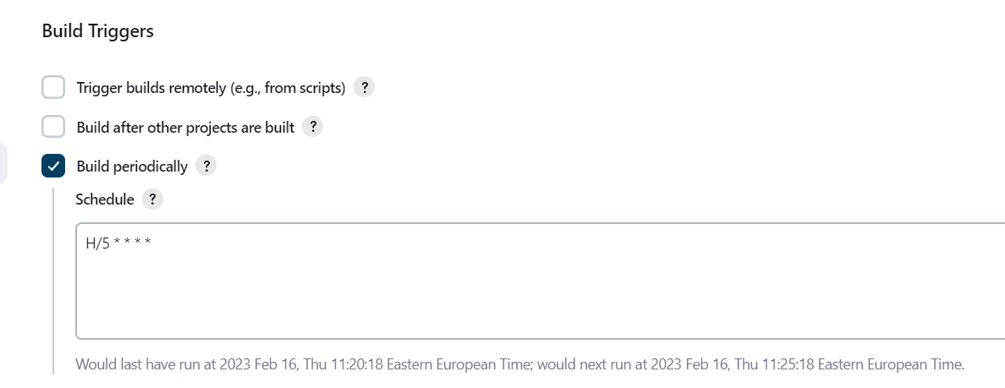

To stop restart or start Jenkins go to directory where Jenkins.war is stored and insert such commands

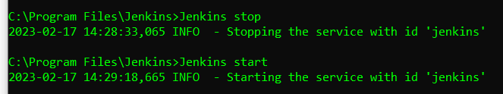

Nodes/ Remote run

<https://www.youtube.com/watch?v=V2ejGOY_uJI> – for remote ubuntu/for local windows – this method works only with local machines

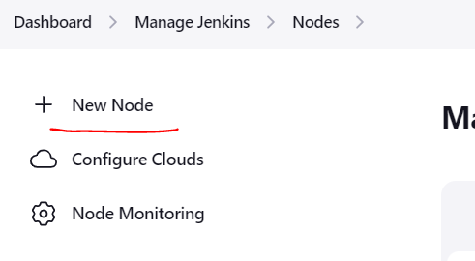

Input labels to search nodes by them, make sure that all needed technologies and hostname are listed

Remote Root Directory – home folder for node-agent, if not exist it will be created automatically

Usage – the node will be active on demand but it have to be connected first to the master

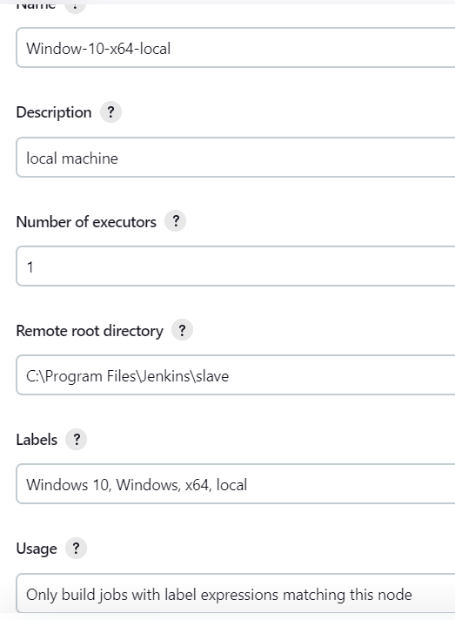

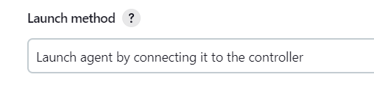

In Global security make this launch method enable by selecting Random for TCP port for inbound agents

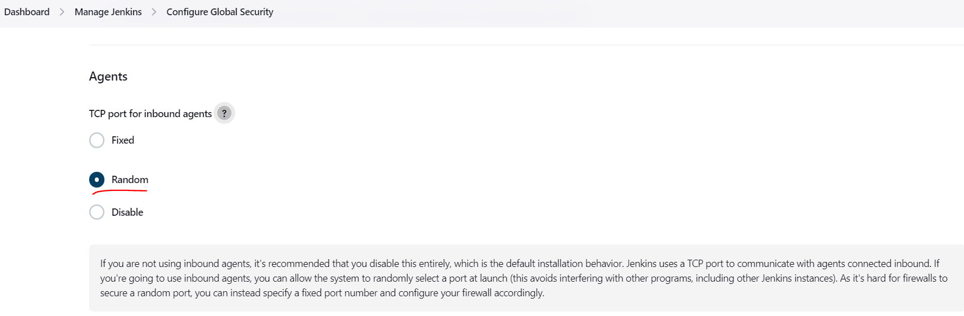

Download agent.jar and input to Remote Root Directory of slave\node

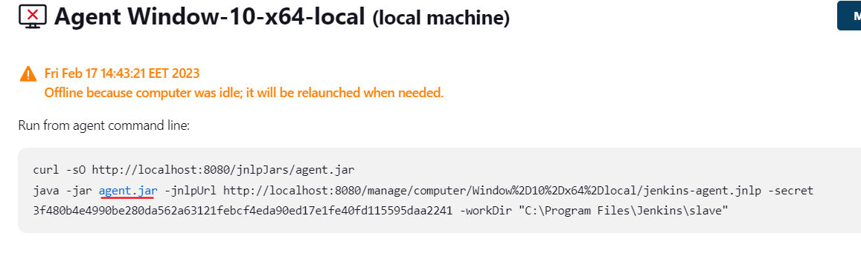

Copy and run the command inside bush from location of agent.jar

 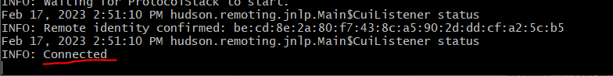

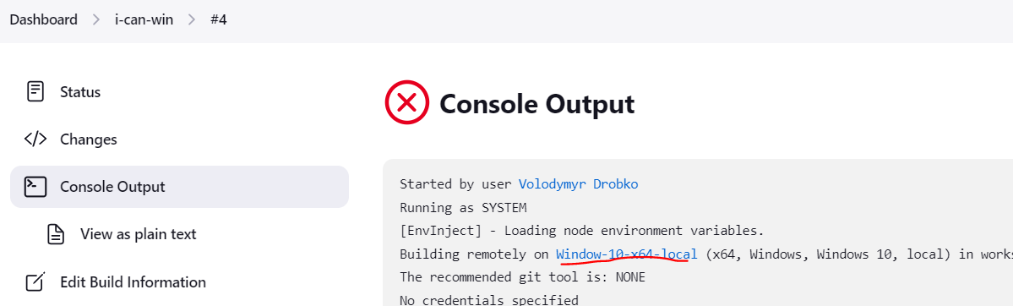

Integrate Jenkins with Automation framework

You can list all suites in plugin that have to be run

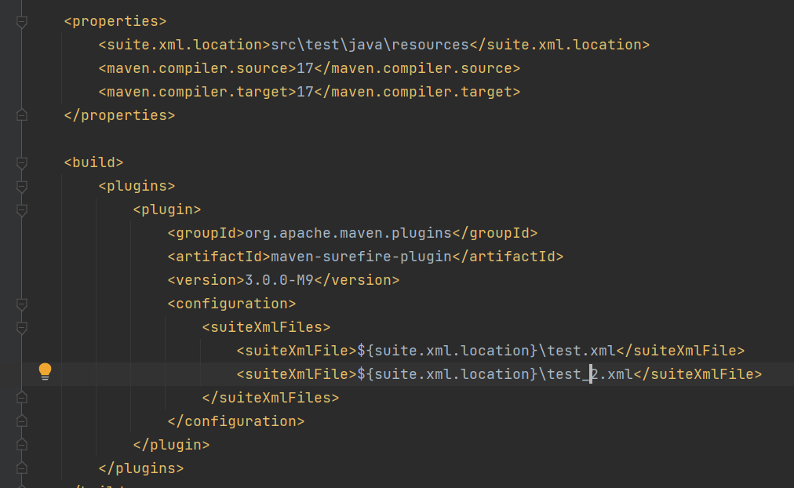

To select different test suites

If you want to select exect suite from Jenkins set up like here:

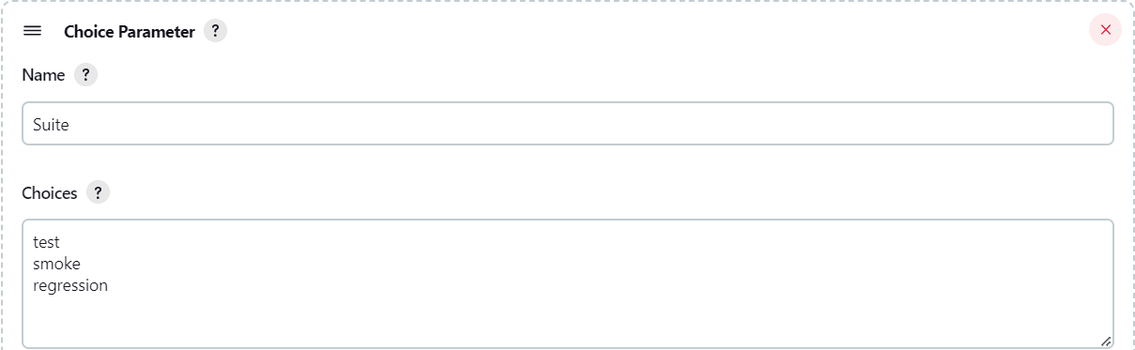

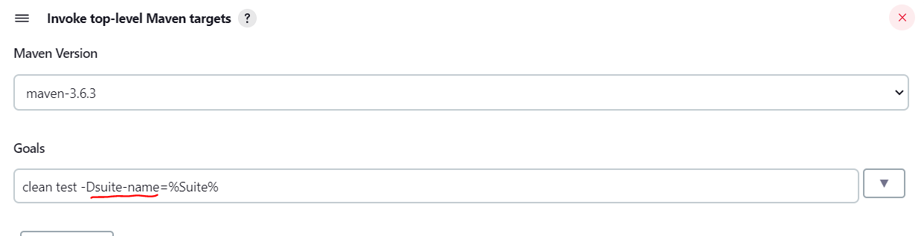

Suite-name – parameter from pom.xml

Suite – system variable created for current job

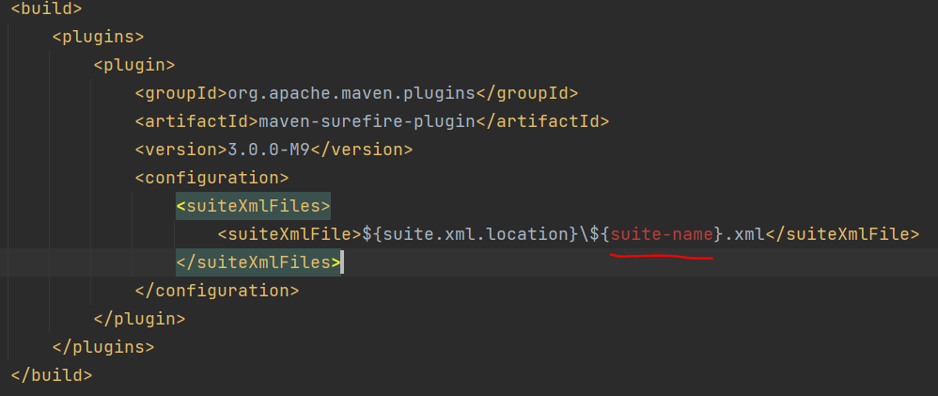

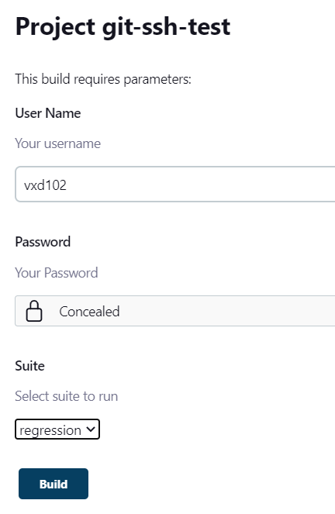

General - Advanced

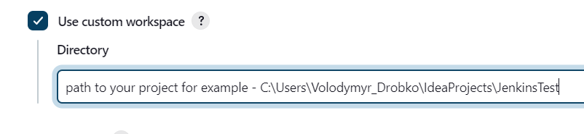

Publish reports with Jenkins

For TestNG reporting

Plugin: TestNG Results

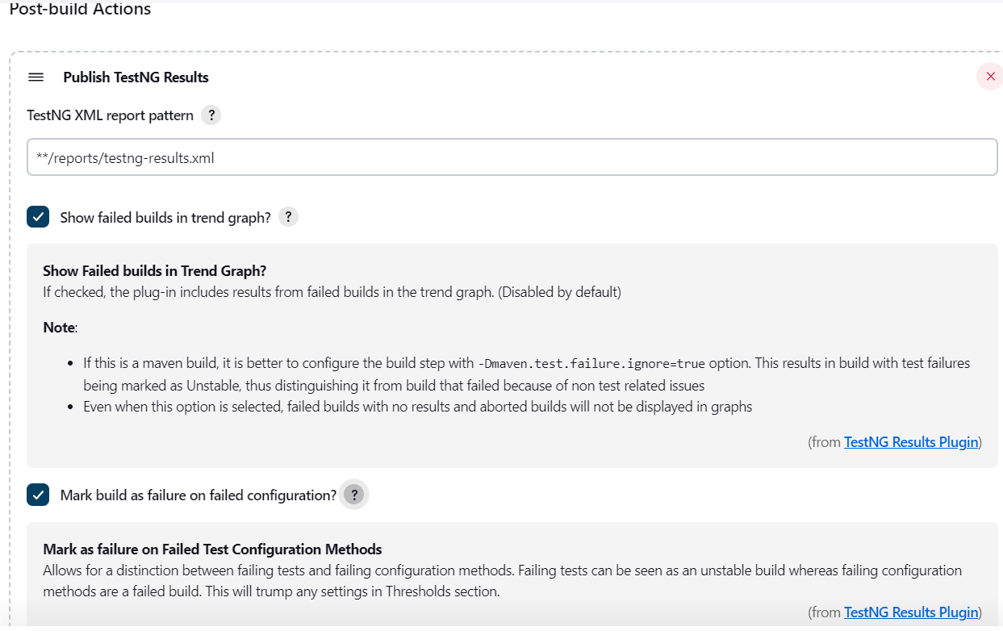

It is better to create a new folder for reports and redefine surefire plugin to generate reports in that directory, also you sould redefine clean plugin to clean old data

Clean plugin:

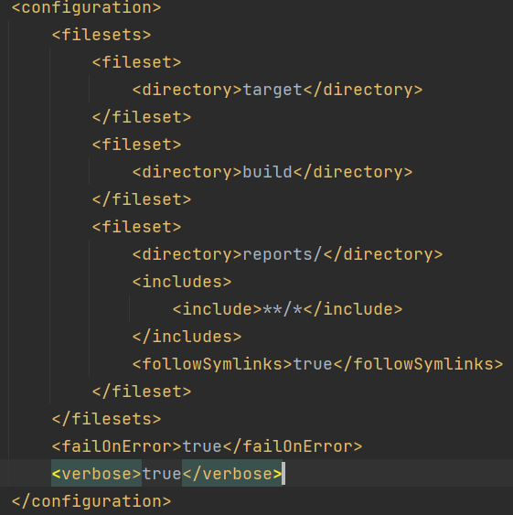

Fileset – which directory to delete

what means include>**/*</include>

The **\*\*/\*** pattern in the **include** element matches any file or directory in the current directory or any subdirectories.

For example, **<include>**/*.java</include>** would match any Java source files in the current directory or any subdirectories.

Therefore, **<include>**/*</include>** will match any file or directory in the current directory or any subdirectories, effectively including everything in the given plugin execution or goal.

what mean **followSymlinks**

Symbolic links are a type of file that contains a reference to another file or directory in the filesystem. When the **followSymlinks** parameter is set to **false** (which is the default value), the plugin will delete the symbolic link file itself, but it won't follow the link and delete the target file or directory.

On the other hand, when **followSymlinks** is set to **true**, the plugin will follow the link and delete the target file or directory as well.

what means <failOnError>true</failOnError>

In the context of the Maven Clean plugin, the **<failOnError>true</failOnError>** configuration means that if any error occurs during the execution of the plugin (for example, if a file or directory cannot be deleted), then the build will fail and stop immediately. This means that if the plugin fails to delete any file or directory specified in the configuration, the build will stop, and any subsequent build steps will not be executed.

what means <verbose>true</verbose>

In the context of the Clean Plugin in Maven, the **<verbose>** element with a value of **true** enables the output of more detailed information during the execution of the clean goal.

By default, the Clean Plugin will print only the names of the directories and files that are being deleted. However, setting the **<verbose>** element to **true** will provide more information about the progress of the deletion process, such as the number of files and directories that have been deleted.

SureFire plugin:

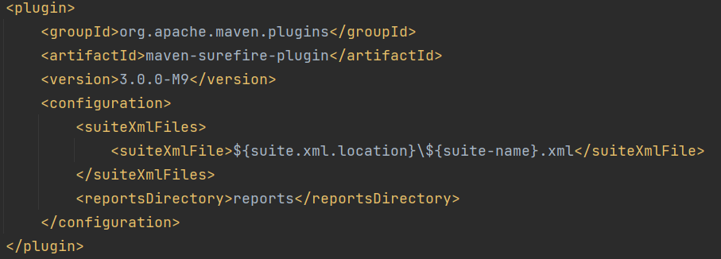

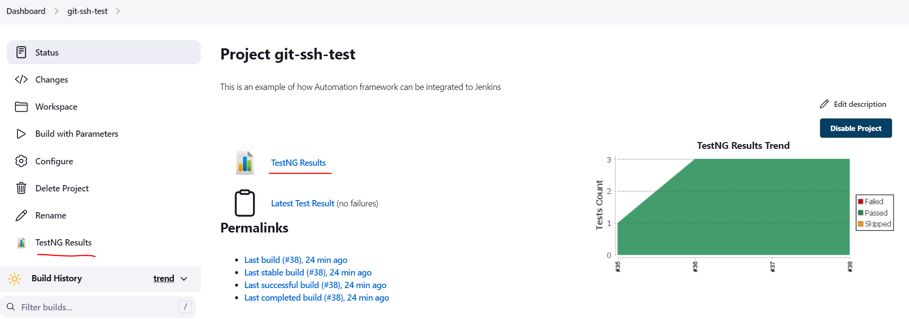

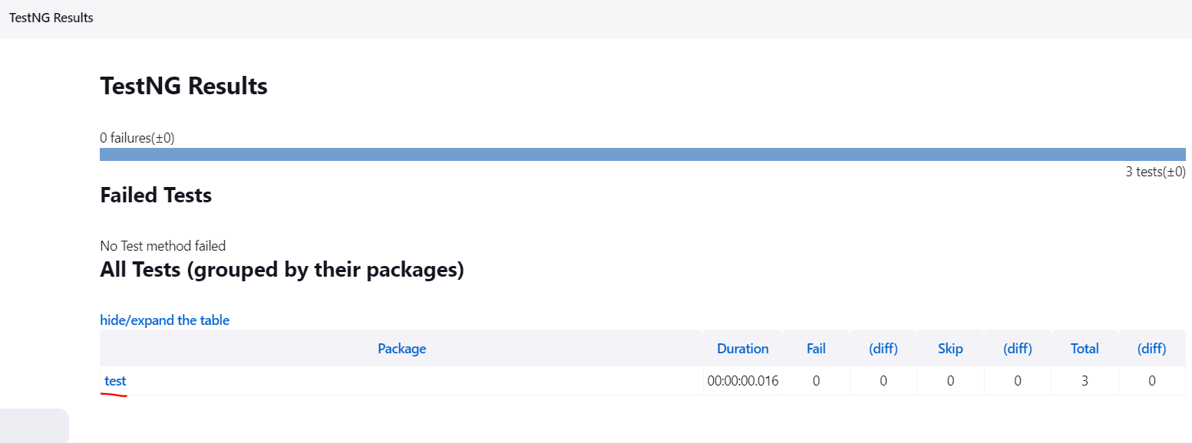

test – name of package from compiler

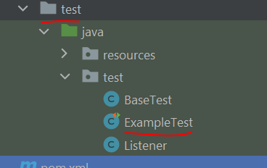

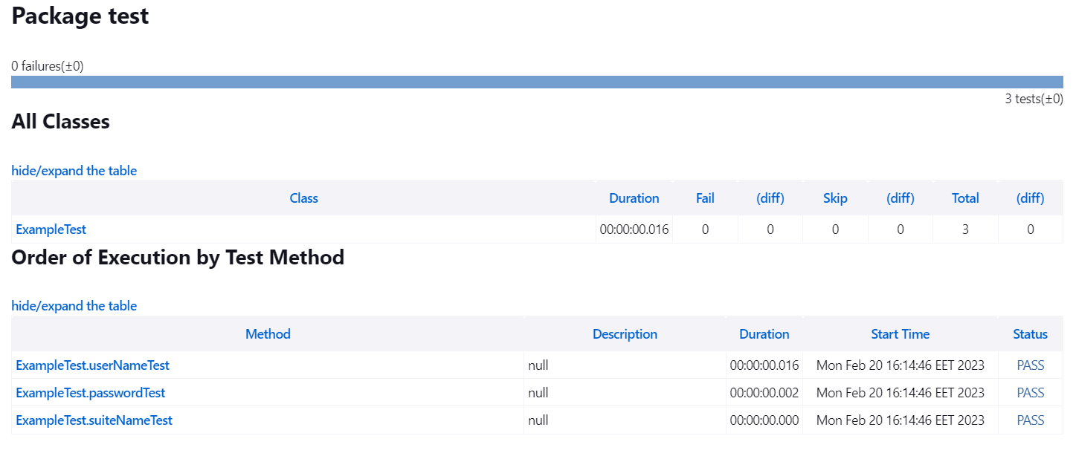

Trending the results of run:

Plugin: Test Results Analyzer

Just install and be happy

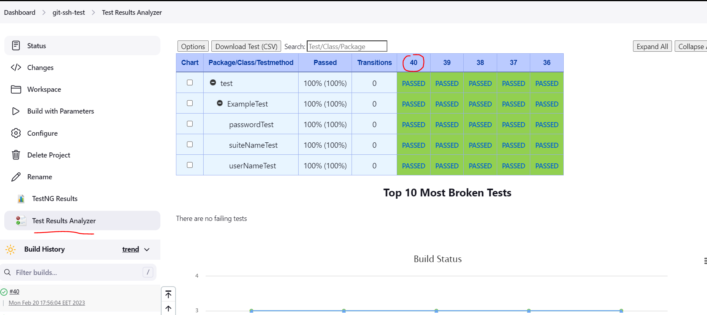

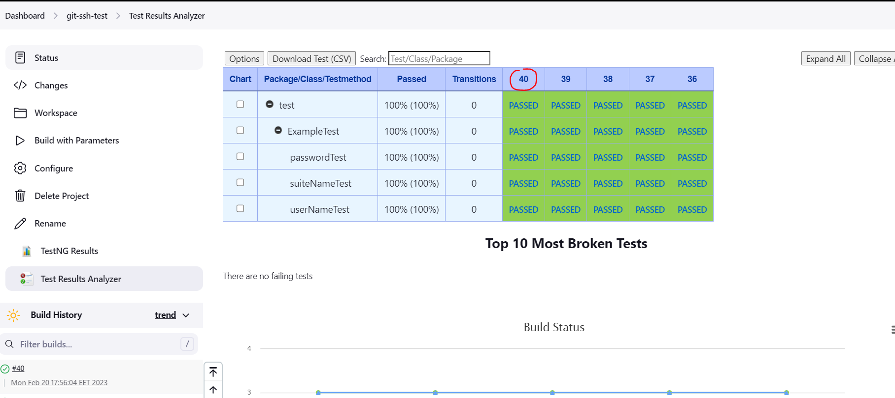

Extent Reporting Framework

Plugin: HTML Publisher Plugin

Specify path to the project: in job Configuration go to General section click Advanced button and select Use custom workspace

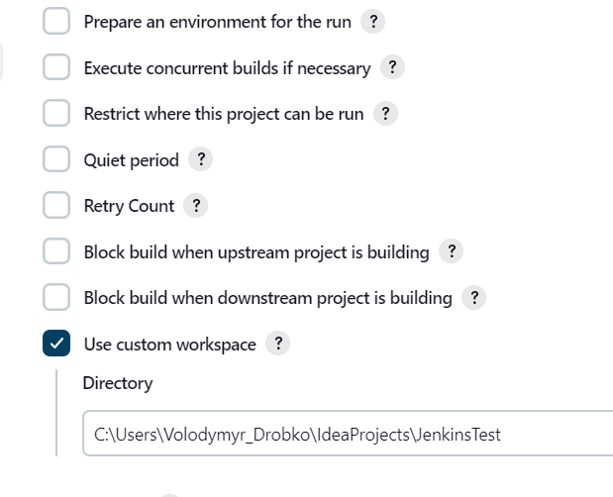

Then go to Post Build steps and add step Publish HTML Reports

Reports in pipeline:

pipeline {

agent any

environment{

reportHome = "C:\\Users\\Volodymyr_Drobko\\IdeaProjects\\jenkins-test\\reports"

}

stages {

stage('Report') {

steps {

echo “Hello Reports”

dir("${reportHome}") {

publishHTML([allowMissing: false, alwaysLinkToLastBuild: true, keepAll: false, reportDir: 'extent', reportFiles: 'Report.html', reportName: 'HTML Report', reportTitles: '', useWrapperFileDirectly: true])

testNG(reportFilenamePattern: '**/testng-results.xml')

}

dir("C:\\ProgramData\\Jenkins\\.jenkins\\jobs\\Html-Report\\htmlreports\\HTML_20Report") {

archiveArtifacts artifacts: 'Regression.html', followSymlinks: false

}

}

}

}

}

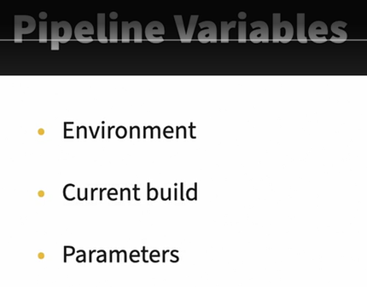

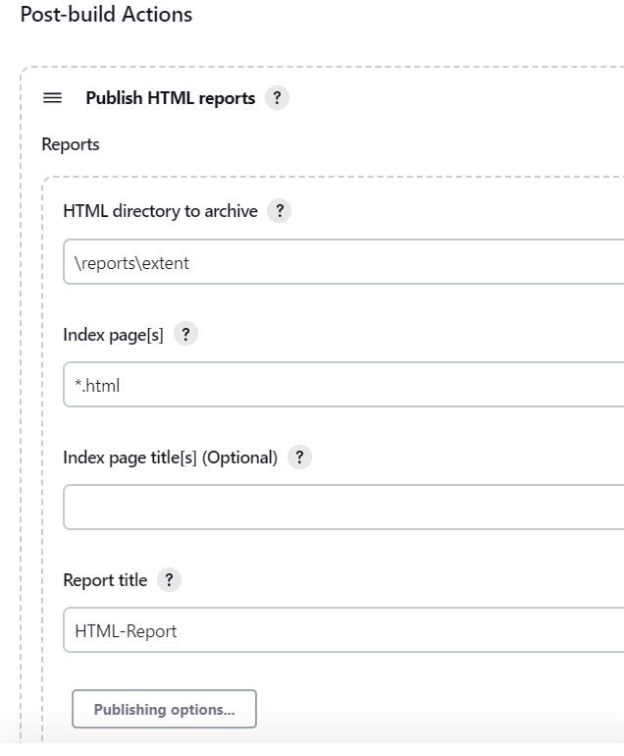

HTML directory to archive – path to your report directory from absolute path to the project folder

Index page – name of report

Report title – name of report after publishing

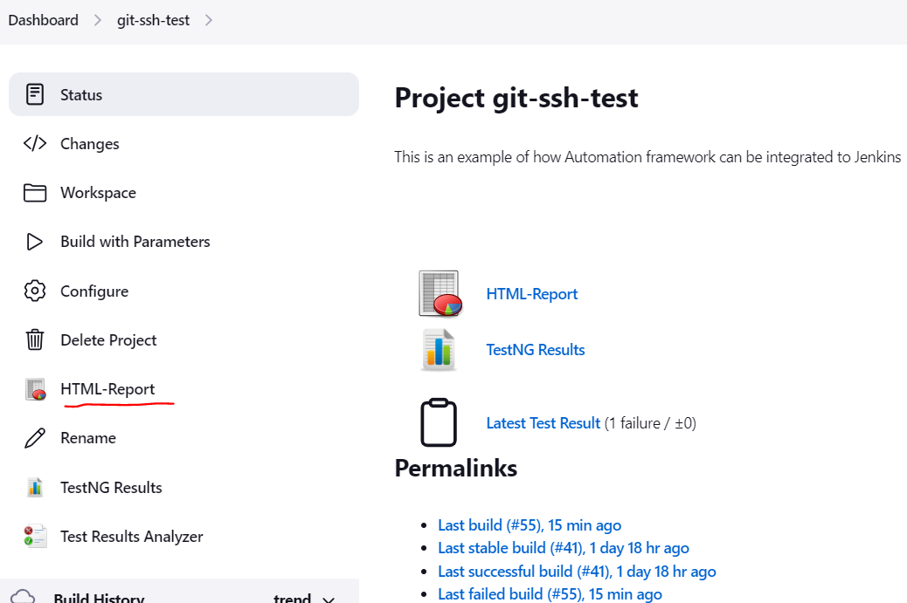

Note:

1. TestNG report can find report by related path HTML wants absolute.

2. TestNG report attached on build level, HTML publish report on job level. Why?

The HTML report is published at the job level by default, not at the build level. This means that the report will not be published for every build, but rather once per job.

The reason for this is that the HTML report is typically used to provide a summary of the job's results over time, rather than for each individual build. Publishing a new report for every build would result in a large number of reports that may be difficult to manage or interpret.

However, it is possible to configure the HTML Publisher plugin to publish reports at the build level if needed. To do this, you would need to modify the plugin configuration to specify the HTML report directory for each build.

Keep in mind that publishing HTML reports at the build level may result in a larger amount of data to manage and may not be practical for all use cases. It's important to consider the intended use of the HTML report and the needs of your team when deciding whether to publish the report at the job or build level.

# HTML report after publishing looks broken because of security configuration - **Content Security Policy**

<https://www.jenkins.io/doc/book/security/configuring-content-security-policy/> - documentation

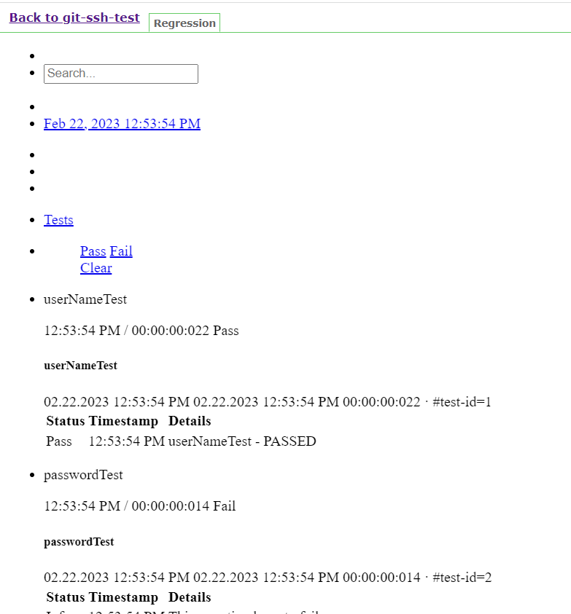

To make report looks as expected is option to disable it in Manage Jenkins – Manage Nodes – select admin node configuration and open Console Scripting:

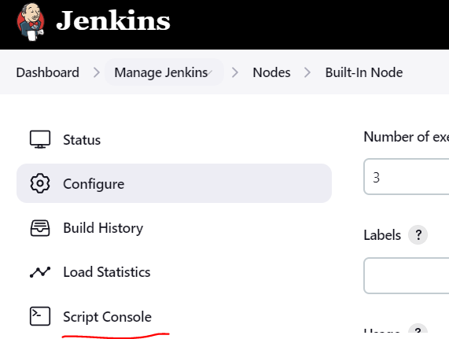

This script will disable all security restrictions, so it is a bad option for remote nodes

System.setProperty("hudson.model.DirectoryBrowserSupport.CSP", "sandbox allow-scripts; style-src 'unsafe-inline' *;script-src 'unsafe-inline' *;")

Set the script and click run

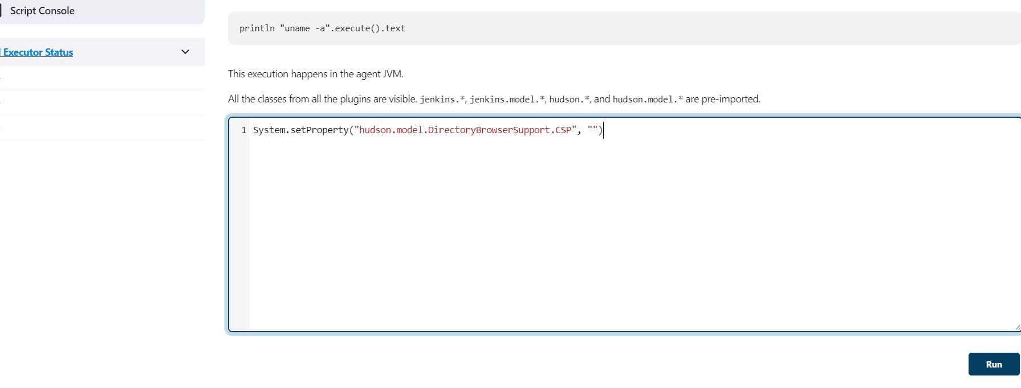

System.setProperty("hudson.model.DirectoryBrowserSupport.CSP", "sandbox; default-src 'none'; img-src 'self'; style-src 'self';") – default security configuration set back after you do not need to view report

PIPELINES

Plugin: Blue Ocean

Open blue ocean

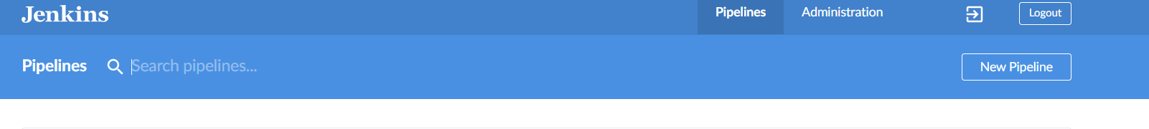

Click New Pipeline

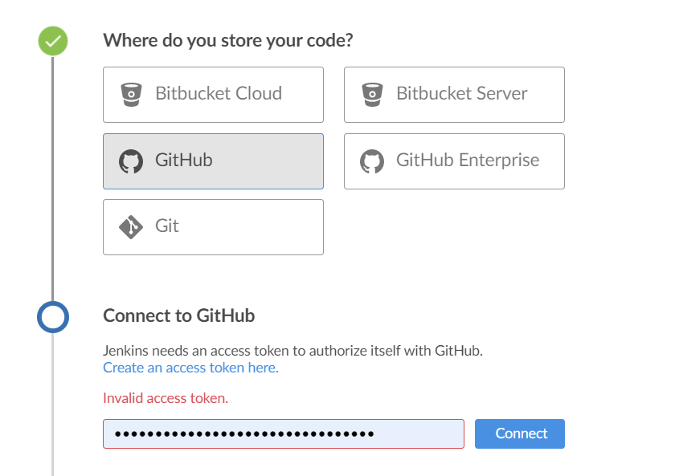

Go to git and create token by user icon – Settings – Developer Settings – Personal access tokens

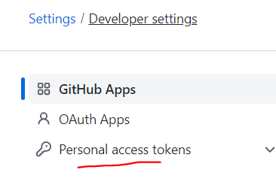

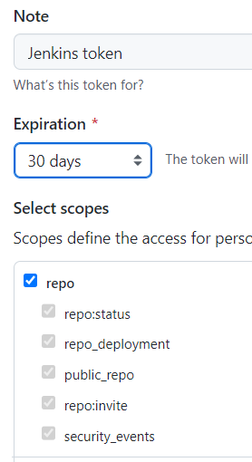

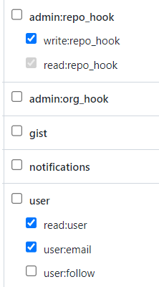

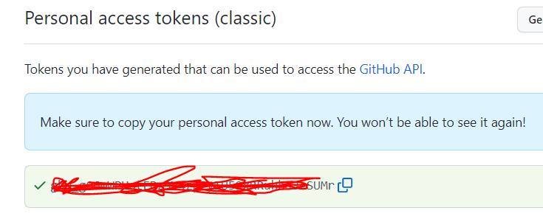

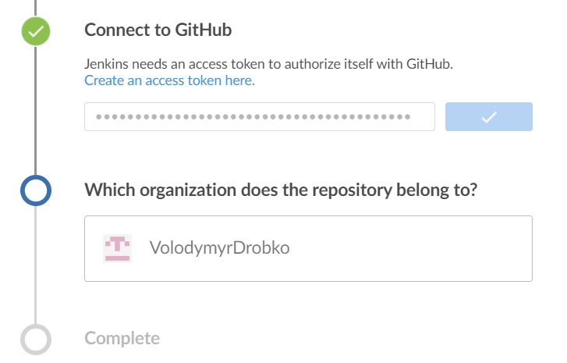

Click on organization – in my case VolodymyrDrobko and select repository from list and click Complete

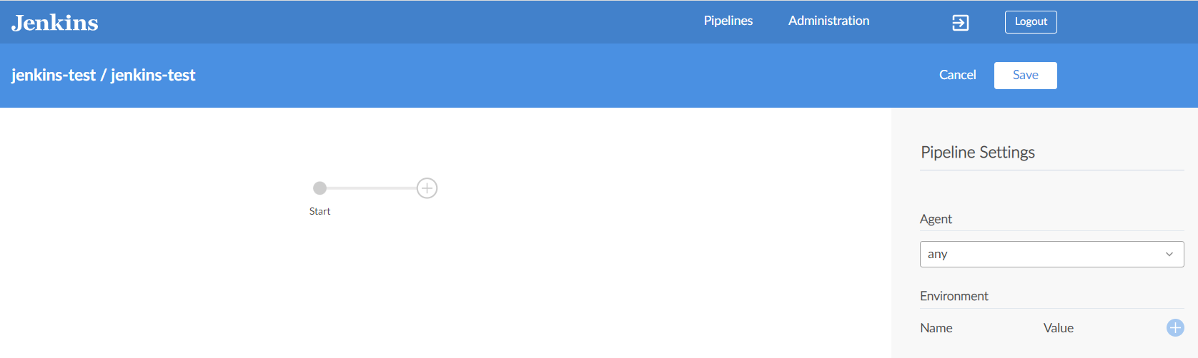

Build all stages and click save then select branch where Jenkins file will be saved

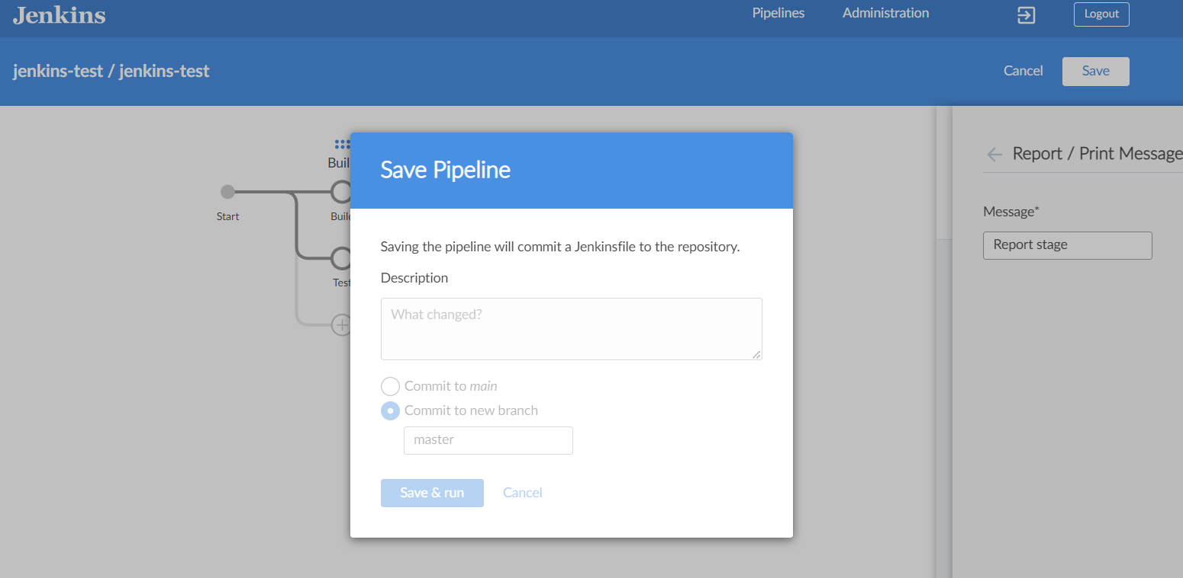

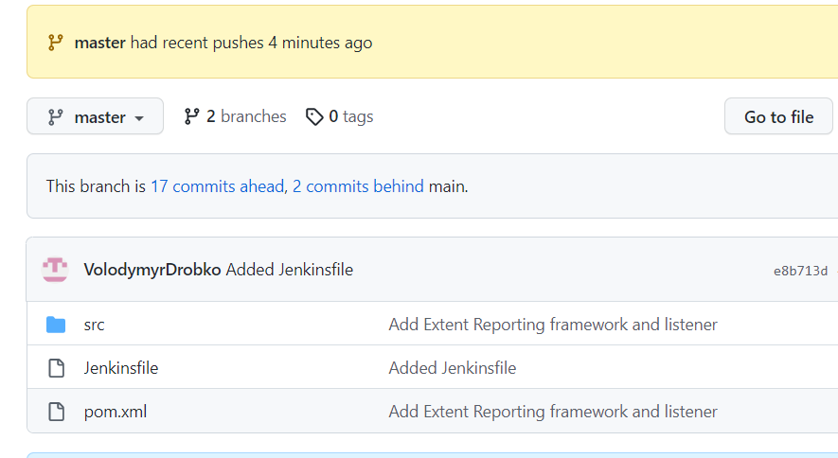

Jenkinsfile is added

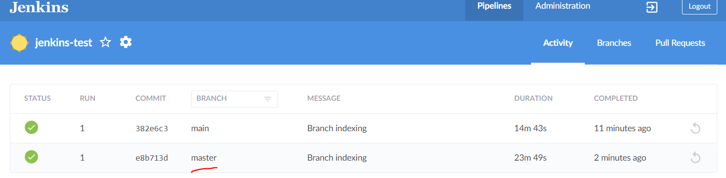

Job was run you can check status by clicking on branch

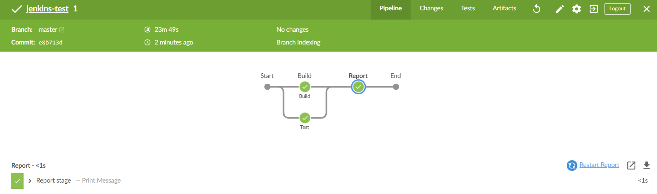

Pipeline Syntax:

A pipeline configuration has three required sections: an agent section, a stages section, and the stages section must have at least one stage with at least one step.

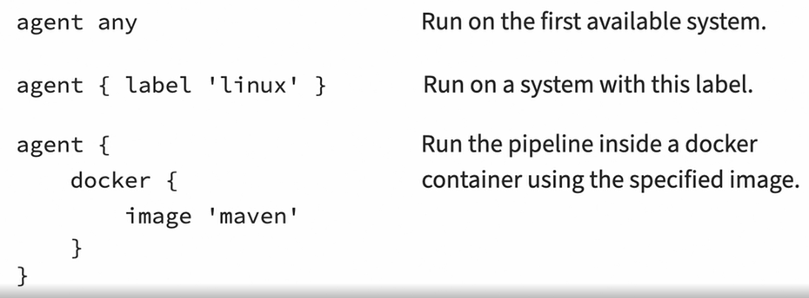



Agent none – delegate agent selection for stage levels so we can use different agents for different stages

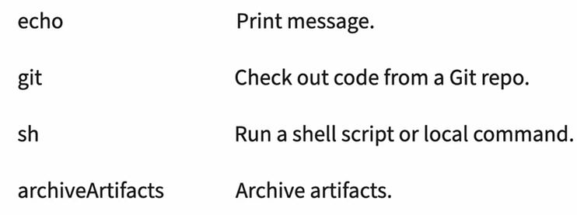

On Windows use bat instead of sh

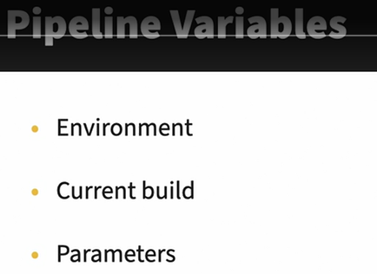

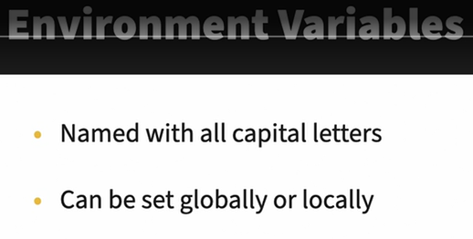

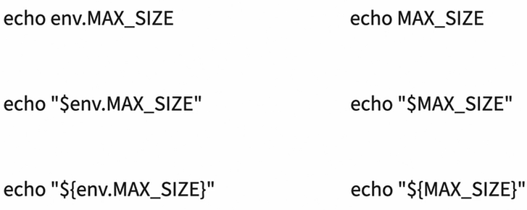

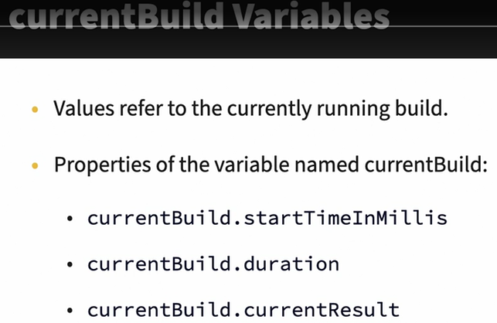

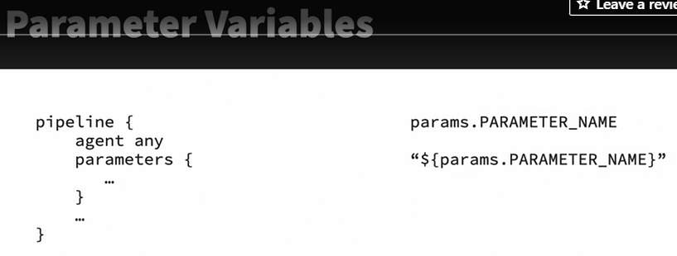

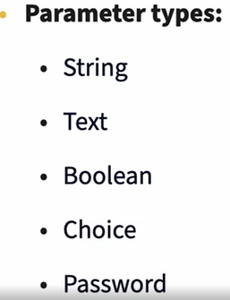

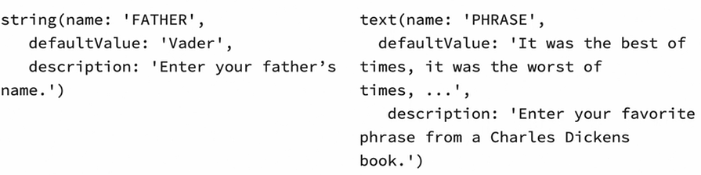

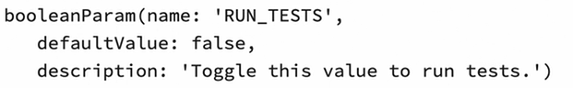

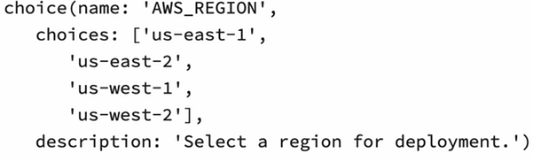

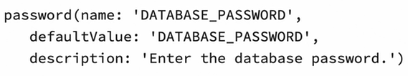

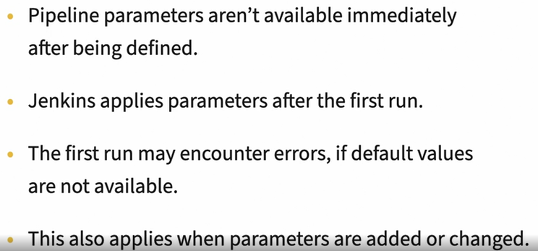

Conditions:

